The First 10 Days
6th Grade
Unit 1 Astronomy
Day 1 | Topic: Electricity & Magnetism  Learning Target: I will be able to ask questions about and recognize the relationship between magnetism and electricity.  Phenomenon: Lightning Bolts and Power Lines  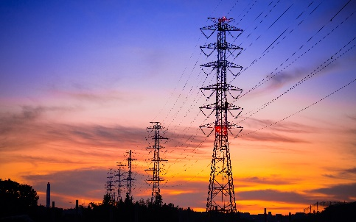  ENGAGE:  - Show students the above images (lightning bolts, power lines) side by side and provide several minutes of thinking in the “alone zone.”  - Ask students to draw the images at the top of their papers and jot down a few descriptors for each. For example:  white-blue  - Show additional images of phenomena. Provide time for students to categorize them as either more like the lightning or more like the power line. (Possible images inserted below) Encourage students to simply write/label each photo to include in their list. For example, “boy sliding.”  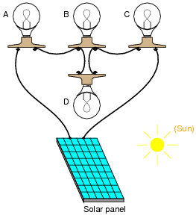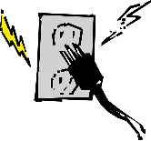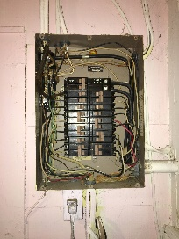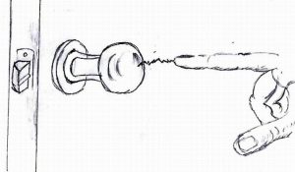  Closure: Have students to share their chart with the rest of the class developing claims about the relationship between magnetism and electricity.
Day 2 | Topic: Electricity and Magnetism  Learning Target: I will discuss my decisions and reasons for how I created my chart.  Phenomenon: Lightning Bolts and Power Lines  - Have students to take out and review their charts from the previous lesson.  - Provide time for students to engage in partner conversation to discuss their decisions and reasons.  Model partner conversation aloud and make a conversation starter sentence visible (on the board/screen). For example, “I chose to put the _____________ under the __lightning/power lines__ because ________.”  Then model for students how to show their partner that they listened to their contribution and either agree/disagree. For example, “I also thought the _______ should go under the ____________ but I thought it should go for a different reason. I thought it should go there because ________.”  Facilitate large group coversation using the following prompts:  - Allow volunteers to share their decisions/reasons for the phenomena shown.  Was there anything I showed you that may have fit under both categories? Allow students to engage in partner conversations to make a decision, and then allow a volunteer to provide any overlapping phenomena.  - How did you decide to distinguish one category over the other?  - Are there any words you know that may allow us to give these groups specific names? Allow students to engage in partner conversations to consider this, and then allow a volunteer to provide any ideas.  - There are two words people will use that might help us. The word static, which means to stay still. Then there is also the word, current, which means flowing in a definite direction, like an ocean current. Allow students to engage in partner conversations to consider this, and then allow a volunteer to provide their ideas.  - If students have not already indicated that one category occurs naturally and the other is human engineered, then also ask the question If we need to distinguish between one naturally occurring and one engineered by humans, which group would be labeled accordingly?  Closure: Have students to state if they choose to make any changes to their chart and why or why not. Have students explain why they maintain the decisions on their chart.
Day 3 | Topic: Electricity and Magnetism  Learning Target: I can use investigations to explain the relationship between electricity and magnetism.  Phenomenon: Lightning Bolts and Power Lines  Review: Teacher can discuss most important questions from previous lesson’s discussion.  Learning Target: I will discover why things cling.  Engage  - Transition into the explore phase by providing time for students to record any questions they might have about any of the phenomena you have presented to them. Consider the use of a Jamboard, Nearpod, etc. for students to post their questions.  - After reading students’ questions summarize them all by saying, so one thing we are all kind of wanting to know is, “How do these things work? How do they do they happen?”  Teacher will do “Stuck Up Balloon” demonstration for the class to see and discuss.  Stuck-Up Balloon  Blow up a balloon and tie the end so that the balloon stays inflated. Hold the balloon against the  wall and see if it will stick. What happens? Briskly rub the balloon across a piece of fur or wool  or even your hair (works best if your hair is clean and dry). For wool, you can use a sweater,  sock, scarf, or rug. Does the balloon stay? Can you explain what happened?  Closure: Have students review the demo and use it to answer the learning target for the lesson.
Day 4 | Topic: Electricity and Magnetism  Learning Target: I will use investigation to explain the difference between attraction and repulsion.  Phenomenon: Lightning Bolts and Power Lines  Review: Class review their understanding about what’s happening in the lightning bolt and power lines phenomenon. This will serve as background information to develop claims for today’s lesson.  Explore  - S5P2.3-Electricity and Magnetism-Lesson 3-Static Electricity Stations Recording Sheet  Teacher will go through #2-5 of the demonstrations from the above link with students completing the Lab Sheet appropriately.  Closure: Students can answer the learning target amongst themselves and use today’s investigations as evidence.
Day 5 | Topic: Electricity and Magnetism  Learning Target: I will use investigation to explain the effects of the build-up and release of static electricity.  Phenomenon: Lightning Bolts and Power Lines  Review: Class review their understanding about what’s happening in the lightning bolt and power lines phenomenon. This will serve as background information to develop claims for today’s lesson.  Explore  - S5P2.3-Electricity and Magnetism-Lesson 3-Static Electricity Stations Recording Sheet  Teacher will go through #6-9 of the demonstrations from the above link with students completing the Lab Sheet appropriately.  Closure: Students can answer the learning target amongst themselves and use today’s investigations as evidence.
Day 6 | Topic: Electricity and Magnetism  Learning Target: I will explain how to build an electromagnet and increase its strength.  Phenomenon: Teacher creating an electromagnet as a demo using the following link:  S5P2.3-Electricity and Magnetism-Lesson 2-Magic Magnets Lab  Review: Students review the relationship between electricity and magnetism  Explain: Students complete the chart that accompanies the demo in the following link:  S5P2.3-Electricity and Magnetism-Lesson 2-Magic Magnets Lab  Closure: Students discuss how changing the number of coils or battery size affects how many paper clips the electromagnet could pick up.
Day 7 | Topic: Magnetic Fields  Learning Target: I can develop testable questions about a magnetic field from the lesson’s phenomenon.  Phenomenon:  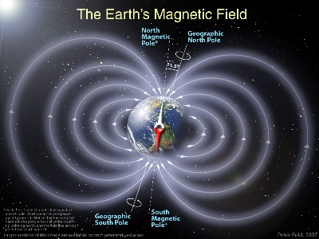  Show students the model of Earth’s magnetic field. Provide time for individual consideration of the model. Encourage students to critique the model: consider what the model does a good job of showing, and then to consider what the model does not do a good job of explaining.  Provide time for partner conversation to critique the model. Set the expectation that each partner must show that they were listening and contribute something new. Consider modeling the rules for conversation.  For example,  Student A: I noticed that the model does a good job of pointing out that there are 2 north poles.  Student B: Yea! I noticed that too, but I also thought it didn’t do a good job of telling me why there were 2 north poles. I thought there was just one.  Facilitate large group conversation. Allow volunteers to first share parts of their critique. Then prompt students to generate questions that can be investigated. For example:  Based on the things you noticed were not explained well in the model, are you wondering about anything?  Record student wonderings in a place visible for all or consider the use of a Jamboard, Nearpod, etc. for students to post their questions.  The following questions can be anticipated:  Why are there 2 north and south poles?  Why is it brighter at the poles?  Why do the lines go out so far?  Why is the Earth magnetic anyway?  Is magnetism what keeps everything on Earth?  Is magnetism why the earth spins?  Review: Students share the questions they develop in the beginning of the lesson and their possible answers.
Day 8 | Topic: Magnetic Fields  Learning Target: I can identify several characteristics of magnets.  Phenomenon: Model of Earth’s magnetic field  Review: Have students review the phenomenon and anything learned from it.  Engage: Have students complete the following: S5P2.3-Electricity and Magnetism-Lesson 1-PROBE.  Closure: Have students discuss their ideas about magnets with their partner(s). Explain their thinking about how magnets work.
Day 9 | Topic: Magnetism  Learning Target: I can use a magnet to demonstrate characteristics of a magnetic field.  Teacher will have as many as possible of these stations prepared to complete demos while students write down observations in the sheets embedded in the link.  S5P2.3-Electricity and Magnetism-Lesson 1-Amazing Magnets Lab Sheet  Closure: Review of observations as it relates to the learning target.
Day 10 | Assessment Day:  Students will individually complete appropriate assessment given by teacher.

