ESO Events for 2016-2017
- Barge Building
- Bridge Building
- Crime Busters
- Deep Blue Sea
- Don’t Bug Me
- Mystery Architecture
- No Bones About It
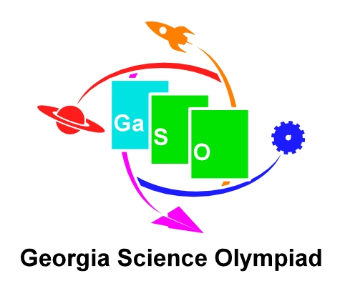
- Paper Rockets
- Rock Hound
- Simple Machines
- Starry Starry Night
- Straw Egg Drop
- Straw Tower
- Water Rockets
- Weather Or Not
- Which Way Is North
- Wildlife Safari
- The 24 Game*
* The 24 Game is a math card game that requires students to use problem solving skills and knowledge of mathematics. Directions for this event are NOT in the ESO manual. 24 Game card sets may be ordered online or purchased at local stores such as Wal-Mart.

The Georgia ESO State Competition will be held at KSU on May 13, 2017.

