ESO Events for 2017-2018
- Backyard Biologists
- Barge Building
- Bridge Building
- Data Crunchers
- Deep Blue Sea
- Disease Detectives
- Don’t Bug Me
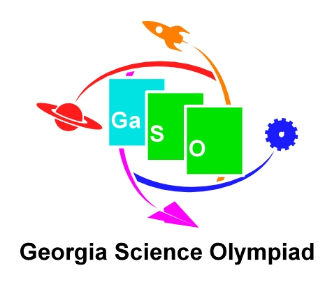
- Mystery Architecture
- No Bones About It
- Paper Rockets
- Rock Hound
- Starry Starry Night
- Straw Egg Drop
- Straw Tower
- Water Rockets
- What’s the Matter
- Which Way Is North
- The 24 Game*
* Directions for these events are NOT in the ESO manual - Backyard Biologist, Data Crunchers and The 24 Game. Visit www.gascioly.org for event directions.

The Georgia ESO State Competition will be held at KSU on May 12, 2017.

