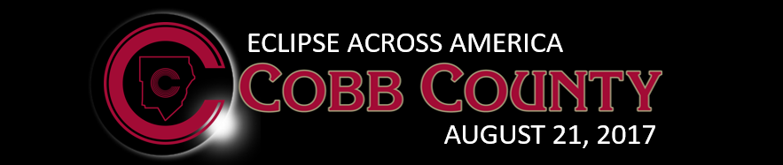

How to Safely View the Eclipse

Experiencing the solar eclipse in Cobb County does not require any special equipment. It is not necessary to actually observe the sun itself to enjoy observing your surroundings during the eclipse. On August 21, simply plan to be outdoors as much as possible between the hours of 2:00 P.M. and 3:00 P.M. so that you can experience the unusual light conditions, strange shadow effects, weather phenomena such as wind or temperature, and even insect & animal behavior that may be unusual. If you are with other people, such as a group of students, note their reactions as well!

Viewing the Eclipse Indirectly Using a “Pinhole Projector”

If you desire to observe the actual disc of the sun during the eclipse, the safest (and most fun!) method is to make your own simple card pinhole projector or, alternatively, a box pinhole projector. Using this method, you will look only at a projected image of the sun instead of looking at the sun itself. Plan to make your pinhole projector ahead of time, so that it will be ready to use on eclipse day. This project, when made into a classroom activity, is an excellent way for teachers to get students involved and excited about the eclipse! For easy step-by-step instructions on how to make one of these tools, go to www.timeanddate.com/eclipse/make-pinhole-projector.html.

Viewing the Eclipse Directly Using Eclipse Viewing Glasses

You should never look directly at the Sun. This also applies during a solar eclipse! In Cobb County, the visible disc of the Sun will NEVER be completely eclipsed on August 21. Therefore, AT NO TIME WILL IT BE SAFE TO LOOK DIRECTLY AT THE SUN WITHOUT SPECIAL EYE PROTECTION! Inexpensive viewing glasses will be widely available at stores in the weeks leading up to August 21. If you desire to use a pair of these glasses, here are some critically important tips:

- Even when the Sun is almost completely eclipsed (in Cobb County it will be about 97% eclipsed near 2:30 P.M.), special eye protection is still required for direct viewing. Even if it seems very dark outside, eye protection must be worn if looking toward the Sun.
- Homemade filters or ordinary sunglasses, even very dark ones, are NOT SAFE for looking at the Sun.
- Safe eclipse viewing glasses will meet the ISO 12312-2 international standard, and this information will be printed on the glasses themselves.
- NASA and the American Astronomical Association have identified five manufacturers that produce eclipse glasses that meet the ISO standard. These manufacturers are: American Paper Optics, Rainbow Symphony, Thousand Oaks Optical, TSE 17, and Baader Planetarium (AstroSolar Silver/Gold film only).
- Inspect your eclipse glasses before use. If they are scratched or damaged, do not use them. Read and follow any instructions that are printed on the glasses or packaged with them. Always supervise and assist children.
- Stand still, look down at the ground, cover your eyes with your eclipse glasses, THEN look up to view the bright Sun through your eclipse glasses. When removing glasses, look downward first, then remove.

NEVER attempt to view the eclipse through an unfiltered camera, telescope, binoculars, or any other optical device.
Additional safe viewing resources from NASA: https://eclipse2017.nasa.gov/safety
Additional safe viewing resources from the American Astronomical Society: https://eclipse.aas.org/eye-safety

