9th-12th Teaching Activities

Pinhole Viewers
This is a GREAT way for students to “see” the eclipse without looking directly at the sun! A simple pinhole viewer projects the image of the sun onto another surface so that students can watch the progression of the eclipse without having to look up at the sun.
Here’s how you make and use it:

How to Make a Simple Pinhole Viewer
Materials Needed- Paper or Cardstock, one thumbtack or pushpin

1. Use the thumbtack or pushpin to create a small hole in the center of one piece of paper or cardstock. The size of the paper can be full size or you may choose to cut one sheet into smaller pieces.

2. Place a blank piece of paper on the ground and stand with your back to the sun. Hold your paper with the pinhole above your head and adjust it until the light passing through it lands on the paper on the ground. Observe the eclipse by using your viewer at intervals!

Want to jazz it up? Print the template on the following pages and allow students to personalize their viewers! Make your pinhole on the location of your school on the map.
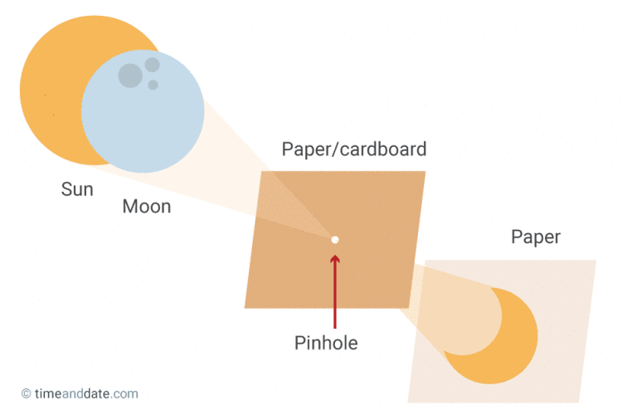

We made viewers, NOW WHAT?
- Share photos of your students using the viewers! Be sure you have proper permissions before publishing online
- Have students attach viewers to a necklace for quick access
- Create mini-challenges for students where they try to use their projectors to see the eclipse on different surfaces (a friend’s shirt, a fencepost, playground equipment, etc). Students can work collaboratively to try and capture each projection with a camera.
- Challenge students to design and build a way to permanently fix their viewers and create a time-lapse video using photographs taken at even time intervals
- Challenge students to plan and carry out an investigation to learn how different size and shaped holes effect how their viewer projects the eclipse
- Challenge students to find and compare their projections using their viewers to sunlight passing through tree branches and sunlight passing through openings made by overlapping their hands (shadow puppet-like)

Further information (and details about 3D printing your viewers!) can be found at:
https://eclipse2017.nasa.gov/2d3d-printable-pinhole-projectors

Eclipse Data Collection Sheet

Time | Eclipse Phase  What does it look like?  Use words and pictures | Additional Observations  Animal behavior, temperature/weather, etc.

Note for Teachers:
Data collection is an important part of scientific observation and study. Don’t miss this chance to record significant data about a real-world phenomenon! You may scaffold for your students by providing certain data on the table and asking them to fill in what’s missing (for example, you may write in the time intervals and require them to collect the other data at the given intervals). You may also leave the chart completely blank and use this as an opportunity for students to design their own plan for observing- encourage student groups to compare results afterwards! When appropriate, students should be transferring their data into graphs, and then use their data to support scientific claims
Additional Resources:
Each of the following activities is designed with high school students in mind and is recommended by NASA for use in relation to the October 14th,2023 and April 8th, 2024 eclipse. Follow the links (Ctrl + click) for all of the details and instructions!

Change Pairs
Analyze and compare images taken by the Solar Dynamics Observatory! Click here:
https://sdo.gsfc.nasa.gov/gallery/main

Simulation
Observe what the eclipse will look like in different locations, including yours. Click here:
https://eclipse2024.org/eclipse-simulator/

Modeling Meaningful Eclipses
From the Jet Propulsion Laboratory in Pasadena, CA. Click here:
https://nightsky.jpl.nasa.gov/docs/ModelMeaningfulEclipses2016.pdf

NSTA Eclipse Resources
Eclipse Resources | NSTA

An Opportunity to Practice Three-Dimensional Science Learning
Published in the July/August 2023 edition of NSTA’s Science Scope. Click here:
https://www.nsta.org/science-scope/science-scope-julyaugust-2023/2023-and-2024-solar-eclipse-double-header

NASA’s Main Eclipse Website
https://solarsystem.nasa.gov/eclipses/home/
https://solarsystem.nasa.gov/eclipses/2023/oct-14-annular/overview/
https://solarsystem.nasa.gov/eclipses/2024/apr-8-total/overview/

Fact Sheet:
2023 Eclipse Fact Sheet

