The First 10 Days of Digital Lessons
8th Grade Science

These lessons are designed to address possible learning gap between 7th Grade Science and 8th Grade Science.
Day 1 | Topic: What Is It?  Learning Target: I will be able to state why classification is important.  Phenomenon: The Blob “The blob, a brainless mystery organism that can solve mazes, makes its public debut”  By Alex Horton, Washington Post, adapted by Newsela staff  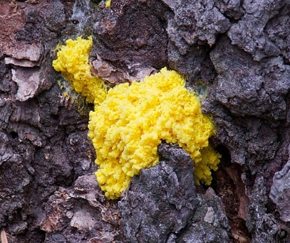  Caption: It is called the blob. Physarum polycephalum is a unicellular organism neither plant, mushroom nor animal and capable of learning despite its lack of a brain and nervous system. It is pictured at the Paris Zoological Park in France in October 2019. Photo: Stephane De Sakutin/AFP/Getty Images  ENGAGE:  - From this picture and the information above, have students create questions only about this blob and how it functions. Encourage students to keep their questions scientifically based.  - Students write everything they know about the kingdoms of organisms mentioned in the caption from their memory (no research, yet).  Fungi Plant Animal  Students asked to consider and explain the usefulness of categorizing living things into kingdoms.  (Teacher Hint: Allow students time in the alone zone, and then to talk with partners perhaps in a virtual chat room. Allow volunteers to make their thinking visible. Use this as an opportunity to model expectations for listening/contributing. For example, one student volunteer may say, “Categorizing makes it easier to figure out what you’re talking about.” You may want to ask them to elaborate on what they mean. Another student may raise their hand to contribute; but try to respect the necessary time it may take for the original student to express themselves. Make this explicit to the students as well.)  Closure: Allow students to get in pairs or groups to compare their kingdom charts and create a modified chart from everyone’s contribution.
Day 2 | Topic: Classification  Learning Target: I will define the 6 kingdoms by specific characteristics.  Phenomenon: The Blob  Have students review why classification is important and yesterday’s kingdom charts. Ask a representative to share their characteristics for each. Ask if there is anyone that disagrees or would like to add anything.  Review the phenomenon and keep up a visual to which students can repeatedly refer.  EXPLORE:  - Ask students if anyone can add additional kingdoms and their characteristics from memory.  - Students will explore about the blob by reading Washington Post . From the reading, students may choose to modify their charts of kingdoms and make a prediction as to how the they will decide to classify the new organism (blob). (Teacher Hint: Ask students to use a pen to circle the kingdom they think the blob will most likely be categorized. Below their table of characteristics students should also explain why they think the blob will be categorized as _______.)  Students obtain and communicate a more complete set of patterns in characteristics that are used to classify organisms into one of the six kingdoms, as well as, explore the history of developing the modern six kingdom classification system. Students add to the table created in the engage phase as they obtain additional information.  Resource: HMH Online Textbook Unit 1, Lesson 5  - Closure: Have students (either individually or in groups) explain how their chart changed after reading the article and the text. Is there anything they added or took away? What were any misconceptions about the kingdoms and how were they corrected?
Day 3 | Topic: Developing a Claim  Learning Target: I can use evidence to support my claim.  Phenomenon: The Blob  Review the chart of the 6 kingdoms and the characteristics of each.  Explore  Students reread the article in Washington Post about the blob.  Students highlight characteristics of the blob that can help them make a decision about the best fit for its kingdom. Students then organize these characteristics under each kingdom. For example:  Archaea Bacteria Protist Fungi Plant Animal  Unicellular Unicellular Unicellular Can be Uni Has a memory Can work mazes  Students then decide if they have enough information to make an informed decision/claim.  (Teacher Hint: Students will most likely decide that they do not have enough information.)  Make explicit to students that their objective is to make a claim as to the best kingdom for classification of this blob based on obtained textual/video evidence. Preview the format for students’ claims:  Guided Question: In what kingdom is the blob characterized?  Students provided time to obtain additional information about the blob (graphic organizer from explore used when reading NewsELA article ) and then organize their thinking in order to make a claim about its classification:  Video: WIRED  Audio: NPR  Additional Text Resources: Slime Mold Express, The Blob: Slime Molds  Closure: Students will share their knowledge on the 6 kingdoms and characteristics and how they can apply this knowledge to develop their claim.
Day 4 | Topic: Developing a Claim  Learning Target: I can use evidence to support my claim.  Phenomenon: The Blob  Review: Students explain the importance of sufficient evidence to support a claim.  Explore  Students will continue research from previous day obtaining information about the blob to support the claim they developed which answers the guided question. “In which kingdom is  the blob characterized?” During this research, students will continue to complete the graphic organizer. Students may even choose to modify their claim pending the results of their research.  Resources:  Video: WIRED  Audio: NPR  Additional Text Resources: Slime Mold Express, The Blob: Slime Molds  Graphic Organizer:  Closure: Students will review characteristics of each kingdom and provide examples of organisms in each.
Day 5 | Topic: Defending a Claim  Learning Target: I can use evidence to defend my claim.  Phenomenon: The Blob  Review: Students explain the importance of sufficient evidence to support a claim.  Explain  Each student will discuss their claim to answer the guided question, “In which kingdom should the blob characterized?” Along with the claim, students must also use their research to defend the claim. In addition, they must state their alternate claim and why they chose it.  As students are presenting their information, the other students should take notes deciding if they agree or disagree. Also, students should have the option of modifying their claim based on the evidence of others  Once all students have stated their claim and evidence, students will share who they agree with the most and why.  Closure: Review of all the claims & evidence submitted to answer the guided question.
Day 6 | Topic: Making Thinking Visible  Learning Target: I can use data to defend a claim and dispute a counterclaim.  Phenomenon: The Blob  Review: Teacher reiterates how data can be use to support a claim and develop a counter claim.  Explain  Students make their thinking visible to partners. Based on conversations, students edit (in pen) their CER organizer to add to/take away evidence and/or reasons.  (Teacher Hint: Before students begin partner discussions, review and/or set the expectations for productive discourse.  Background Resources:  Science Talk  (Suggested guidelines created by students provided within the article/video.)  Taking Science to School: Chapter 7  "7 Participation in Scientific Practices and Discourse." National Research Council. 2007. Taking Science to School: Learning and Teaching Science in Grades K-8. Washington, DC: The National Academies Press. doi: 10.17226/11625.  As a follow up, students take a thinking poll to show where their thinking about how the blob should be classified. Students discuss how the data informs them of the alternate/counter claim.  (Teacher Hint: Thinking polls can be posted in the classroom on large scale using sticky notes on a graphic organizer like the one students used to explore or digital through https://www.polleverywhere.com/)  Students finalize their thinking by constructing an argument about the best category for the blob. Students must align their argument using patterns in characteristics like other organisms in that kingdom. Students must also present evidence as to how a counter claim for a different kingdom could be argued, but also present why this counter claim is insufficient based on the known structures and functions of the blob.  (Teacher Hint: Prior to writing consider providing students with a writing rubric. In addition, depending on students’ experiences with CER/writing in science you may need to make explicit how to read the rubric. Provide examples of exemplary writing as needed.)
Day 7 | Topic: Classifying Matter  Learning Target: I can classify matter according to the distribution of particles.  Phenomenon: show pictures of a gas, liquid, and solid  Have students to create 3 questions only that relate to their differences in structure.  Review: have students to reiterate how classification works  Expand  Students collect, interpret, and analyze information in order to classify them into a cladogram via the PBS Nova classroom activity, “The Missing Link.”  After completing the cladogram, students then transition into the study of physical sciences by interpreting and analyzing images/descriptions (physical and chemical properties, structure/function) of different types of matter (e.g. pure substances, mixtures). Students follow the same general procedures provided in “The Missing Link” to classify the different types of matter into a cladogram.  particles evenly distributed different types of particles, connected or bonded same types of particles, connected or bonded  particles unevenly distributed only one type of particle cannot be broken down by physical or chemical mean  different types of particles sharing space, but disconnected same type of particles sharing space, but disconnected can only be broken down by chemical means  can be broken down by either physical or chemical means unique set of properties connected, or bonded, properties are different from the unique set of properties of the individual particles  properties stay the same of the different types of particles that are sharing space share space set, or constant, ratio of different types of particles  Images to Correspond with Above Descriptions:  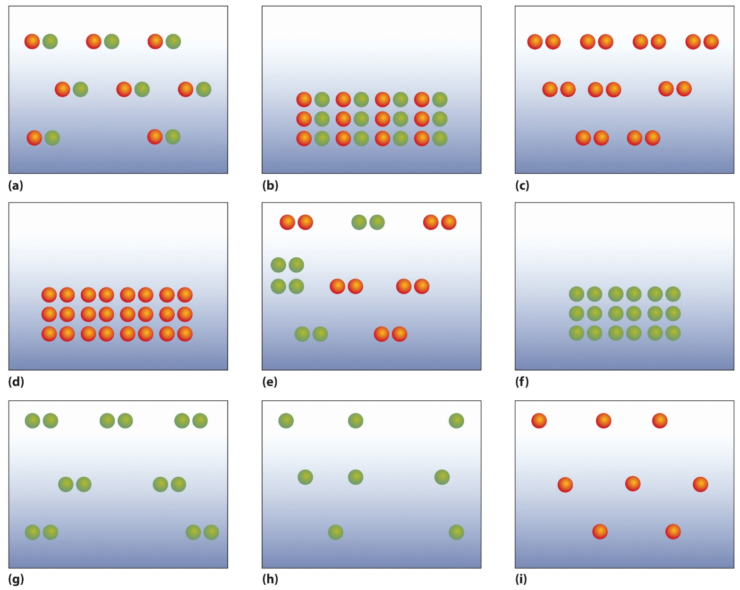  Review: Students relate the structure to the function of a solid, liquid, and gas.
Day 8 | Topic: Classifying Matter  Learning Target: I can classify matter according to the distribution of particles.  Phenomenon: show pictures of a gas, liquid, and solid  Review: Students review the differences in particles between a solid, liquid, and gas  Explore  Students use resources to find real life examples for each of the following listed below in the table:  particles evenly distributed different types of particles, connected or bonded same types of particles, connected or bonded  particles unevenly distributed only one type of particle cannot be broken down by physical or chemical mean  different types of particles sharing space, but disconnected same type of particles sharing space, but disconnected can only be broken down by chemical means  can be broken down by either physical or chemical means unique set of properties connected, or bonded, properties are different from the unique set of properties of the individual particles  properties stay the same of the different types of particles that are sharing space share space set, or constant, ratio of different types of particles  Closure: Students explain how classification of matter compares to classification of living things
Day 9 | Topic: Classification of Matter  Learning Target: I can use my knowledge and reasoning skills to answer questions.  Students use resource to answer questions in lesson as a whole, in groups, and individual to prepare for assessment.  https://www.chem.purdue.edu/gchelp/atoms/elements.html  HMH Online Textbook: Unit 1, Lesson 4 pp 60 - 72
Day 10 | Assessment Day:  Students will individually complete assessment questions from GMAS Study/Resource Guide for Parents/Students Grade 8:  (Teacher will choose questions from this unit to be a part of the assessment.)

