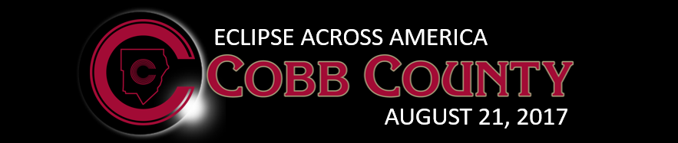
6-8 Teaching Activities
Solar Eclipse Day

Pinhole Viewers
This is a GREAT way for students to “see” the eclipse without looking directly at the sun! A simple pinhole viewer projects the image of the sun onto another surface so that students can watch the progression of the eclipse without having to look up at the sun.
Here are three options:

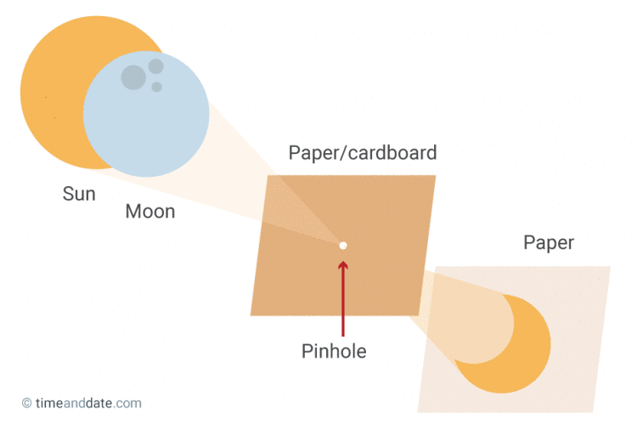
How to Make a Simple Pinhole Viewer

Materials Needed- Paper or Cardstock, one thumbtack or pushpin

1. Use the thumbtack or pushpin to create a small hole in the center of one piece of paper or cardstock. The size of the paper can be full size or you may choose to cut one sheet into smaller pieces.

2. Place a blank piece of paper on the ground and stand with your back to the sun. Hold your paper with the pinhole above your head and adjust it until the light passing through it lands on the paper on the ground. Observe the eclipse by using your viewer at intervals!

Want to jazz it up? Print the template on the following page and allow students to personalize their viewers! Make your pinhole on the location of your school on the map. Have students cut out the star shape and watch them marvel at how the irregular shape projects the eclipse

Further information (and details about 3D printing your viewers!) can be found at: https://eclipse2017.nasa.gov/2d3d-printable-pinhole-projectors

Engineer a Cereal Box Pinhole Viewer
Materials needed: Empty Cereal Box, White paper, foil, ~3mm nail, tape

For step by step photos, click here: http://hilaroad.com/camp/projects/eclipse_viewer/eclipse_viewer.html

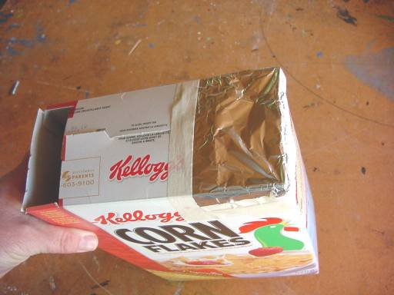

We made viewers, NOW WHAT?
- Share photos of your students using the viewers! Be sure you have proper permissions before publishing online
- Have students attach viewers to a necklace for quick access
- Create mini-challenges for students where they try to use their projectors to see the eclipse on different surfaces (a friend’s shirt, a fencepost, playground equipment, etc). Students can work collaboratively to try and capture each projection with a camera.
- Challenge students to design and build a way to permanently fix their viewers and create a time-lapse video using photographs taken at even time intervals
- Challenge students to plan and carry out an investigation to learn how different size and shaped holes effect how their viewer projects the eclipse
- Challenge students to find and compare their projections using their viewers to sunlight passing through tree branches and sunlight passing through openings made by overlapping their hands (shadow puppet-like

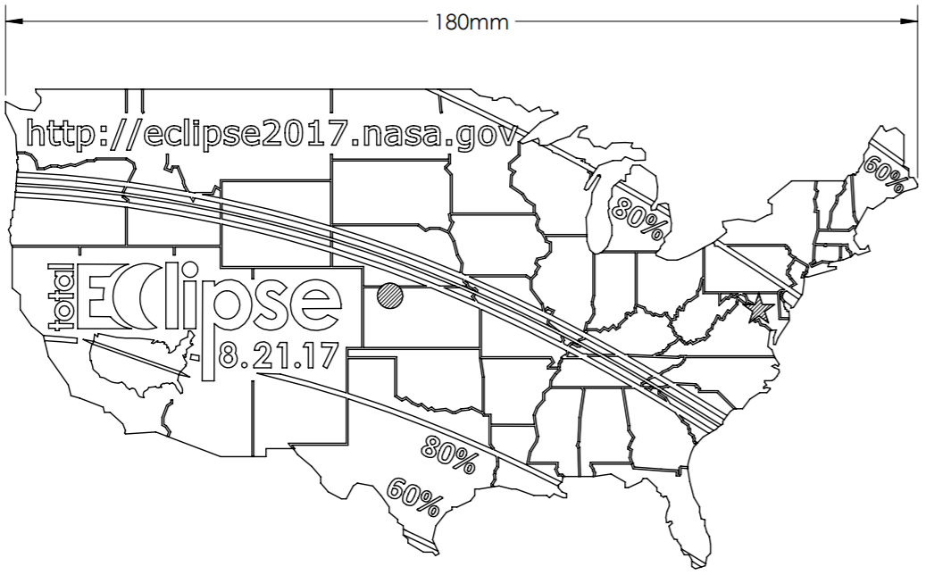

Eclipse Data Collection Sheet
Customizable for each grade level

Note for Teachers:
Data collection is an important part of scientific observation and study. Don’t miss this chance to record significant data about a real-world phenomenon! You may scaffold for your students by providing certain data on the table and asking them to fill in what’s missing (for example, you may write in the time intervals and require them to collect the other data at the given intervals). You may also leave the chart completely blank and use this as an opportunity for students to design their own plan for observing- encourage student groups to compare results afterwards! When appropriate, students should be transferring their data into graphs, and then use their data to support scientific claims.
Time | Eclipse Phase  What does it look like?  Use words and pictures | Additional Observations  Animal behavior, temperature/weather, etc.

Eclipse Activities by Grade

6th

Earth, Moon, and Sun Model
Standards: S6E2. Obtain, evaluate, and communicate information about the effects of the relative positions of the sun, Earth, and moon.
S6E2.b. Construct an explanation of the cause of solar and lunar eclipses.

Teacher Resource:
https://www.astrosociety.org/wp-content/uploads/2016/10/uitc93.pdf

Students engage in the content through an orderly sequence of seven different investigations that provide an in-depth understanding of the phenomenon of eclipses.
Potential driving questions investigated through these activities include
Driving Questions for a Solar Eclipse:
• Why do solar eclipses happen?
• Why is the appearance of the Moon the same size as the Sun in our sky?
• How are lunar phases and a solar eclipse related?
• How often do solar eclipses occur?
• Why don’t we see an eclipse every month?
• Why are solar eclipses not visible to every location on Earth?

Citizen Science (NASA)
Standards: S6E2. Obtain, evaluate, and communicate information about the effects of the relative positions of the sun, Earth, and moon.

Materials: GLOBE Observer App, thermometer

Procedure:
GLOBE Observer (Note: Total Eclipse on the GLOBE Observer app will be unlocked August 18)
https://www.nasa.gov/feature/goddard/2017/nasa-looks-to-the-solar-eclipse-to-help-understand-the-earth-s-energy-system NASA invites eclipse viewers around the country to participate in a nationwide science experiment by collecting cloud and air temperature data and reporting it via their phones. NASA GO will feature a special eclipse experiment. With the app and a thermometer, citizen scientists can help observe how the eclipse changes atmospheric conditions near them, and contribute to a database used by students and scientists worldwide in order to study the effects of the eclipse on the atmosphere. Observers in areas with a partial eclipse or outside the path of totality are encouraged to participate alongside those within totality.
Watch video and download the GLOBE Observer app
Explanations on how to use the app and resources on GLOBE Observer website: https://observer.globe.gov/science-connections/eclipse2017

Eclipse Activities by Grade

7th Grade

Eclipse Misconceptions
Standards: S7L2 c. Construct an argument that systems of the body (Cardiovascular, Excretory, Digestive, Respiratory, Muscular, Nervous, and Immune) interact with one another to carry out life processes.
.

Resource: https://eclipse2017.nasa.gov/eclipse-misconceptions

In this online NASA article, students examine misconceptions about electromagnetic radiation during a total solar eclipse and its effect on humans

Citizen Science
Standards: S7L4 a. Construct an explanation for the patterns of interactions observed in different ecosystems in terms of the relationships among and between organisms and abiotic components of the ecosystem.

Resource: http://www.inaturalist.org/projects/life-responds-total-solar-eclipse-2017/
Life Responds (California Academy of Sciences ) – Document changes in animal behavior, birds going to sleep, cats and dogs being confused, as a solar eclipse is in progress. In this opportunity for research, you will make scientifically-valuable observations of many aspects of this behavior. Join the California Academy of Sciences in conducting research into behavioral changes in plants and animals during a total solar eclipse.

Eye Safety
Standards: S7L2 c. Construct an argument that systems of the body (Cardiovascular, Excretory, Digestive, Respiratory, Muscular, Nervous, and Immune) interact with one another to carry out life processes.

Teacher Resource: Eclipses and Eye Safety
https://www.astrosociety.org/wp-content/uploads/2017/03/Children_Mar2017_EyeSafety.pdf

This online article discusses eye safety with both direct and indirect observation when watching the solar eclipse.

Resource: Discover proper eyewear to be used for viewing with Eclipse Viewing Glasses https://eclipse2017.nasa.gov/safety

Resource: Flyer with details for manufacturers specifications
https://eclipse2017.nasa.gov/sites/default/files/publications/safe_glasses_flyer.pdf

Eclipse Activities by Grade

8th Grade

Earth, Moon, and Sun Model
Standards: S8P4. g. Develop and use models to demonstrate the effects that lenses have on light (i.e., formation an image) and their possible technological applications.
S8P1. Obtain, evaluate, and communicate information about the structure and properties of matter.

Materials:
Resource: Short article about proper eyewear to be used for viewing with Eclipse Viewing Glasses https://eclipse2017.nasa.gov/safety
Resource: Flyer with details for manufacturers
https://eclipse2017.nasa.gov/sites/default/files/publications/safe_glasses_flyer.pdf

Procedure: (Claim, Evidence, Reasoning)
- Students read about eye safety precautions along with a flyer about safety specifications and guidelines for using solar viewers.
- Students should be given Eclipse Viewing Glasses and make a claim, with evidence and reasoning as to whether or not they are save to use for viewing.

Citizen Science
Standards: S8P4. Obtain, evaluate, and communicate information to support the claim that electromagnetic (light) waves behave differently than mechanical (sound) waves.
S8P4. Construct an explanation using data to illustrate the relationship between the electromagnetic spectrum and energy.

Materials: GLOBE Observer App, thermometer

Procedure:
GLOBE Observer (Note: Total Eclipse on the GLOBE Observer app will be unlocked August 18)
https://www.nasa.gov/feature/goddard/2017/nasa-looks-to-the-solar-eclipse-to-help-understand-the-earth-s-energy-system NASA invites eclipse viewers around the country to participate in a nationwide science experiment by collecting cloud and air temperature data and reporting it via their phones. NASA GO will feature a special eclipse experiment. With the app and a thermometer, citizen scientists can help observe how the eclipse changes atmospheric conditions near them, and contribute to a database used by students and scientists worldwide in order to study the effects of the eclipse on the atmosphere. Observers in areas with a partial eclipse or outside the path of totality are encouraged to participate alongside those within totality.
Watch video and download the GLOBE Observer app
Explanations on how to use the app and resources on GLOBE Observer website: https://observer.globe.gov/science-connections/eclipse2017

Additional Middle School Resources
Follow the links (Ctrl + click) for all of the details and instructions!

Simulation
Observe what the eclipse will look like in different locations, including yours. Click here:
https://eclipsemega.movie/simulator

Modeling Meaningful Eclipses
From the the Jet Propulsion Laboratory in Pasadena, CA. Click here:
https://nightsky.jpl.nasa.gov/docs/ModelMeaningfulEclipses2016.pdf

An Opportunity to Practice Three Dimensional Science Learning
Published in the March, 2017 edition of NSTA’s The Science Teacher. Click here:
https://eclipse2017.nasa.gov/sites/default/files/The%20Science%20Teacher%20-%20Mar2017%20-%20Total%20Eclipse_An%20Ideal%20Opportunity.pdf

Becoming A Solar Eclipse Outreach Agent
Published in the March, 2017 edition of NSTA’s The Science Teacher. Click here:
https://eclipse2017.nasa.gov/sites/default/files/The%20Science%20Teacher%20-%20Mar2017-%20Becoming%20a%20Solar%20Eclipse%20Outreach%20Agent.pdf

