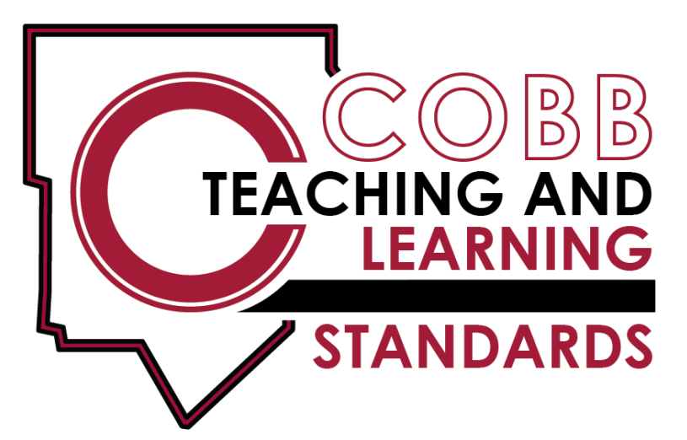

3rd Grade – Math

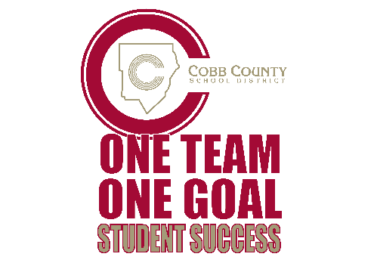
3rd Grade Science

3rd Grade Science Teaching & Learning Framework
Quarter 1 |  | Quarter 2 |  | Quarter 3 |  | Quarter 4
Unit 1  8 weeks | Unit 2  5 Weeks |  | Unit 3  5 weeks | Unit 4  7 weeks | Unit 5  5 weeks |  | Unit 6  6 weeks
Rocks and Minerals | Soils |  | Fossils | Georgia Habitats & Adaptations | Conservation & Recycling |  | Heat
S3E1. Obtain, evaluate, and communicate information about the physical attributes of rocks and soils.  a. Analyze data to classify rocks by their physical attributes using simple tests | S3E1. Obtain, evaluate, and communicate information about the physical attributes of rocks and soils.  b. Plan & carry out investigations to describe properties (color, texture, capacity to retain water & support growth of plants) of soils and soil types (sand, clay, loam).  c. Make observations of the local environment to construct an explanation of how water &/or wind have made changes to rocks &/or soil.  (Clarification statement: Examples could include ripples in dirt on a playground and a hole formed under gutters.) |  | S3E2. Obtain, evaluate, & communicate information on how fossils provide evidence of past organisms.  a. Construct an argument from observations of fossils (authentic or reproductions)to communicate how they serve as evidence of past organisms & environments in which they lived  b. Develop a model to describe the sequence & conditions required for an organism to become fossilized.  (Clarification statement: Types of fossils (cast, mold, trace, and true) are not addressed in this standard.) | S3L1. Obtain, evaluate, & communicate information about the similarities & differences between plants, animals, & habitats found within geographic regions (Blue Ridge Mtns., Piedmont, Coastal Plains, valley & Ridge, and Appalachian Plateau) of Georgia.  a. Ask questions to differentiate between plants, animals, & habitats found within Georgia’s geographic regions.  b. Identify external features & adaptations (camouflage, hibernation, protection, migration, mimicry) of animals to construct an explanation of how these features/adaptations allow survival in their habitat.  c. Use evidence to construct an explanation of why some organisms can thrive in one habitat & not another. | S3L2. Obtain, evaluate, & communicate information about the effects of pollution (air, land & water) and humans on the environment.  a. Ask questions to collect information & create records of sources & effects of pollution on the plants & animals of Georgia.  b. Explore research, & communicate solutions, such as conservation of resources & recycling materials, to protect plants & animals of Georgia. |  | S3P1 Obtain, evaluate, & communicate information about the ways heat energy is transferred & measured.  a. Ask questions to identify sources of heat energy.(Clarification statement: Examples could include sunlight, friction, and burning.)  b. Plan & carry out an investigation to gather data using thermometers to produce tables & charts that illustrate the effect of sunlight on various objects (Clarification statement: The use of both Fahrenheit and Celsius temperature scales is expected.)  c. .Use tools & every day materials to design & construct a device/ structure that will increase/ decrease the warming effects of sunlight on various materials.  (Clarification statement: Conduction, convection, and radiation are taught in upper grades.)

Third Grade Standards

The Cobb Teaching and Learning Standards ( CT & LS ) for science are designed to provide foundational knowledge and skills for all students to develop proficiency in science. The Project 2061’s Benchmarks for Science Literacy and the follow up work, A Framework for K-12 Science Education were used as the core of the standards to determine appropriate content and process skills for students. The focus on a limited number of core disciplinary ideas and crosscutting concepts which build from Kindergarten to high school. The Cobb Teaching and Learning Standards are written with the core knowledge to be mastered integrated with the science and engineering practices needed to engage in scientific inquiry and engineering design. Crosscutting concepts are used to make connections across different science disciplines.
The Cobb Teaching and Learning Standards drive instruction. Hands-on, student-centered, and inquiry-based approaches should be the emphasis of instruction. The standards are a required minimum set of expectations that show proficiency in science. However, instruction can extend beyond these minimum expectations to meet student needs. At the same time, these standards set a maximum expectation on what will be assessed by the Georgia Milestones Assessment System.
Science consists of a way of thinking and investigating, as well a growing body of knowledge about the natural world. To become literate in science, students need to possess sufficient understanding of fundamental science content knowledge, the ability to engage in the science and engineering practices, and to use scientific and technological information correctly. Technology should be infused into the curriculum and the safety of the student should always be foremost in instruction.
The Third Grade Cobb Teaching and Learning Standards for science engage students in making observations and using information they obtained to answer questions. Their communication skills allow them to record findings, analyze data, and recognize the importance of keeping records of observations without making alterations. Third graders add and subtract whole numbers mentally, on paper, and with a calculator. They observe, construct, and measure objects using ordinary hand tools. They observe things with many parts and describe the ways in which the parts influence or interact with one another. They represent objects in the real world with geometric figures, number sequences, graphs, diagrams, maps, and stories. The students will use this information to explain physical attributes of rocks and soils, understand how fossils provide evidence of organisms that lived long ago, describe ways in which heat energy is transferred and measured, identify features of plants and animals within the geographical regions of Georgia, and recognize the effects of pollution on the environment.

Earth and Space Science

S3E1. Obtain, evaluate, and communicate information about the physical attributes of rocks and soils.

- Ask questions and analyze data to classify rocks by their physical attributes (color, texture, luster, and hardness) using simple tests.
(Clarification statement: Mohs scale should be studied at this level. Cleavage, streak and the classification of rocks as sedimentary, igneous, and metamorphic are studied in sixth grade.)
- Plan and carry out investigations to describe properties (color, texture, capacity to retain water, and ability to support growth of plants) of soils and soil types (sand, clay, loam).
- Make observations of the local environment to construct an explanation of how water and/or wind have made changes to soil and/or rocks over time.
(Clarification statement: Examples could include ripples in dirt on a playground and a hole formed under gutters.)

S3E2 | Obtain, evaluate, and communicate information on how fossils provide evidence of past organisms  - Construct an argument from observations of fossils (authentic or reproductions) to communicate how they serve as evidence of past organisms and the environments in which they lived.  - Develop a model to describe the sequence and conditions required for an organism to become fossilized.  (Clarification statement: Types of fossils (cast, mold, trace, and true) are not addressed in this standard.)

Physical Science

S3P1. Obtain, evaluate, and communicate information about the ways heat energy is transferred and measured.

a. Ask questions to identify sources of heat energy.
(Clarification statement: Examples could include sunlight, friction, and burning.)
b. Plan and carry out an investigation to gather data using thermometers to produce tables and charts that illustrate the effect of
sunlight on various objects.
(Clarification statement: The use of both Fahrenheit and Celsius temperature scales is expected.)
c. Use tools and every day materials to design and construct a device/structure that will increase/decrease the warming effects of
sunlight on various materials.
(Clarification statement: Conduction, convection, and radiation are taught in upper grades.)

Life Science

S3L1. Obtain, evaluate, and communicate information about the similarities and differences between plants, animals, and habitats found
within geographic regions (Blue Ridge Mountains, Piedmont, Coastal Plains, Valley and Ridge, and Appalachian Plateau) of Georgia.

a. Ask questions to differentiate between plants, animals, and habitats found within Georgia’s geographic regions.
b. Construct an explanation of how external features and adaptations (camouflage, hibernation, migration, mimicry) of animals allow
them to survive in their habitat.
Use evidence to construct an explanation of why some organisms can thrive in one habitat and not in another.

S3L2. Obtain, evaluate, and communicate information about the effects of pollution (air, land, and water) and humans on the environment.

a. Ask questions to collect information and create records of sources and effects of pollution on the plants and animals.
b. Explore, research, and communicate solutions, such as conservation of resources and recycling of materials, to protect plant & animals.

