3-5 Teaching Activities
Solar Eclipse Day

Pinhole Viewers
This is a GREAT way for students in Grades 3-5 to “see” the eclipse without looking directly at the sun! A simple pinhole viewer projects the image of the sun onto another surface so that students can watch the progression of the eclipse without having to look up at the sun.
Here’s how you make and use it:

How to Make a Simple Pinhole Viewer
Materials Needed- Paper or Cardstock, one thumbtack or pushpin

1. Use the thumbtack or pushpin to create a small hole in the center of one piece of paper or cardstock. The size of the paper can be full size or you may choose to cut one sheet into smaller pieces.

2. Place a blank piece of paper on the ground and stand with your back to the sun. Hold your paper with the pinhole above your head and adjust it until the light passing through it lands on the paper on the ground. Observe the eclipse by using your viewer at intervals!

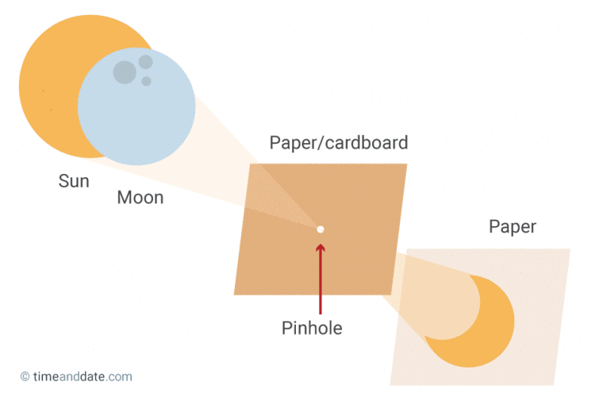
Want to jazz it up? Print the template on the following page and allow students to personalize their viewers! Make your pinhole on the location of your school on the map. Try helping students cut out the star shape and watch them marvel at how the irregular shape projects the eclipse!

We made viewers, NOW WHAT?
- Share photos of your students using the viewers! Be sure you have proper permissions before publishing online
- Have students attach viewers to a necklace for quick access
- Create mini-challenges for students where they try to use their projectors to see the eclipse on different surfaces (a friend’s shirt, a fencepost, playground equipment, etc). Students can work collaboratively to try and capture each projection with a camera.
- Challenge students to design and build a way to permanently fix their viewers and create a time-lapse video using photographs taken at even time intervals
- Challenge students to plan and carry out an investigation to learn how different size and shaped holes effect how their viewer projects the eclipse
- Challenge students to find and compare their projections using their viewers to sunlight passing through tree branches and sunlight passing through openings made by overlapping their hands (shadow puppet-like)

Further information (and details about 3D printing your viewers!) can be found at:
https://eclipse2017.nasa.gov/2d3d-printable-pinhole-projectors

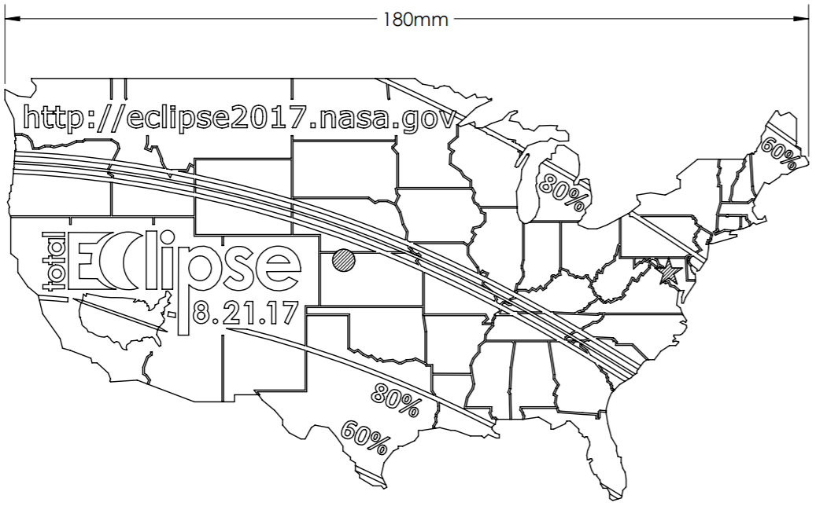

Eclipse Data Collection Sheet
Customizable for each grade level 3-5

Note for Teachers:
Data collection is an important part of scientific observation and study. Don’t miss this chance to record significant data about a real-world phenomenon! You may scaffold for your students by providing certain data on the table and asking them to fill in what’s missing (for example, you may write in the time intervals and require them to collect the other data at the given intervals). You may also leave the chart completely blank and use this as an opportunity for students to design their own plan for observing- encourage student groups to compare results afterwards! When appropriate, students should be transferring their data into graphs, and then use their data to support scientific claims.
Time | Eclipse Phase  What does it look like?  Use words and pictures | Additional Observations  Animal behavior, temperature/weather, etc.

Eclipse Activities by Grade

3rd Grade

The Sun’s Missing Heat | Citizen Scientists
Standards: S3P1. Obtain, evaluate, and communicate information about the ways heat energy is transferred and measured.  a. Ask questions to identify sources of heat energy.  b. Plan and carry out an investigation to gather data using thermometers to produce tables and charts that illustrate the effect of sunlight on various objects.  Materials: Thermometers, data collection sheets, pencils, tape  Procedure:  1. Inform students that they will be measuring the temperature outside before, during, and after the eclipse.  2. In groups, students should plan and design their experiment. They need to consider which thermometers they will use, whether they are measuring air temperature or surface temperature, how many they will use, where they will set them up, how often they will read them, and the jobs of each person in the group (reader, recorder, etc.). Students may need to conduct independent research while planning their investigation.  3. Students should create their own data sheets before proceeding outside- they may do this digitally.  4. Once outside, students should be attending to their data between checking in with the eclipse using their pinhole viewers or eclipse glasses.  5. Students should use the data collected to create graphs. They should prepare a short presentation of their data and should be able to compare and contrast their group with others around them. Students should be able to use their data to support scientific claims regarding what happens to the temperature during an eclipse. | Standards: S3P1. Obtain, evaluate, and communicate information about the ways heat energy is transferred and measured.  a. Ask questions to identify sources of heat energy.  b. Plan and carry out an investigation to gather data using thermometers to produce tables and charts that illustrate the effect of sunlight on various objects.  Materials: Thermometers, The Globe Observer App on a tablet or other mobile device  Procedure:  1. Check out the resources on this website for detailed information regarding student data collection and submissions:  https://observer.globe.gov/science-connections/eclipse2017  2. Students will collect data according to the parameters of this project and be able to view their data alongside that of many others across the country! This is a wonderful opportunity for students to participate in a project of great scale and related to a truly unique phenomenon.

Eclipse Activities by Grade

4th & 5th Grade

Citizen Scientists

Standards: S4E2. Obtain, evaluate, and communicate information to model the effects of the position and motion of the Earth and the moon in relation to the sun as observed from the Earth.

Materials: Thermometers, The Globe Observer App on a tablet or other mobile device

Procedure:
1. Check out the resources on this website for detailed information regarding student data collection and submissions:
https://observer.globe.gov/science-connections/eclipse2017

2. Students will collect data according to the parameters of this project and be able to view their data alongside that of many others across the country! This is a wonderful opportunity for students to participate in a project of great scale and related to a truly unique phenomenon.

Models and Mentors
Standards: S4E2. Obtain, evaluate, and communicate information to model the effects of the position and motion of the Earth and the moon in relation to the sun as observed from the Earth.
Materials: Student created models of the sun, earth, and moon

Procedure:
1. Students will create 3D models of the Earth, sun, and moon. They may use foam balls, inflatable balls, materials brought from home, etc.
2. Students will travel in teams of 3 to visit students in K and 1st grade and model for them what’s happening during the eclipse.

Design Your Own Scavenger Hunt
Standards: S4E2. Obtain, evaluate, and communicate information to model the effects of the position and motion of the Earth and the moon in relation to the sun as observed from the Earth.
Materials: technology that allows students to take photographs
Procedure:
1. After learning about what they should expect during the eclipse, students will work as a class to compile challenges for a photo scavenger hunt that will show what they are learning while they watch the eclipse. It’s important that it be student created!
Here are a few examples:
- Photograph your team modeling the position of the Earth, Sun, and Moon for a group of younger students. (5 points)
- Photograph your pinhole projection on the shirt of one group member. (3 points each)
- Photograph your team dramatically acting out how you feel during the eclipse. (3 points)
- Photograph your team wearing their eclipse glasses and looking up at the sun. (4 points)
- Photograph your team collecting data regarding the eclipse. (7 points)
2. Allow students to have a blast working to complete challenges and collect their memories in photos!

Data Collection
Standards: S4E2. Obtain, evaluate, and communicate information to model the effects of the position and motion of the Earth and the moon in relation to the sun as observed from the Earth.
Materials: student selected-possibly thermometers, cameras, pencil, paper
Procedure:
1. Students will design a system for measuring and collecting data. They should consider what they want to measure and the best means of doing so.
2. Students should carefully collect data before, during, and after the eclipse.
3. Be sure students graph and compare results post-eclipse. They should be able to use their data to support claims surrounding the event.

