How to Access Professional Learning in SLDS
- Log into SLDS
- Choose one of three ways to access the Professional Learning Platform
  - PL Tab on the SLDS menu listing

  - In TKES/LKES section of SLDS, select Professional Learning Opportunities the flyout menu
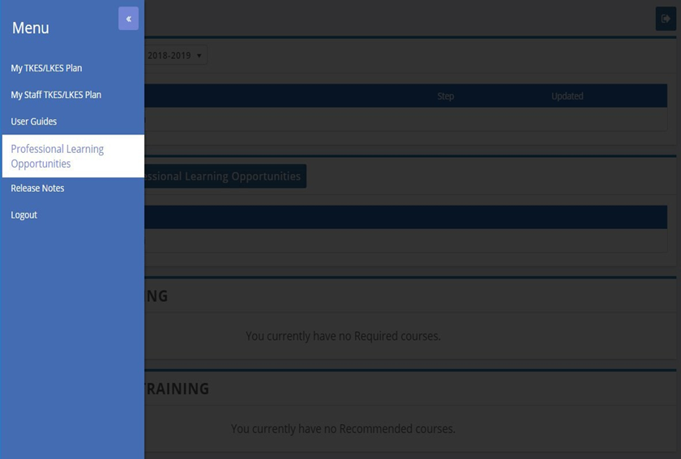

  - In TKES/LKES Plan landing page -Click Professional Learning Opportunities button in the My Courses section 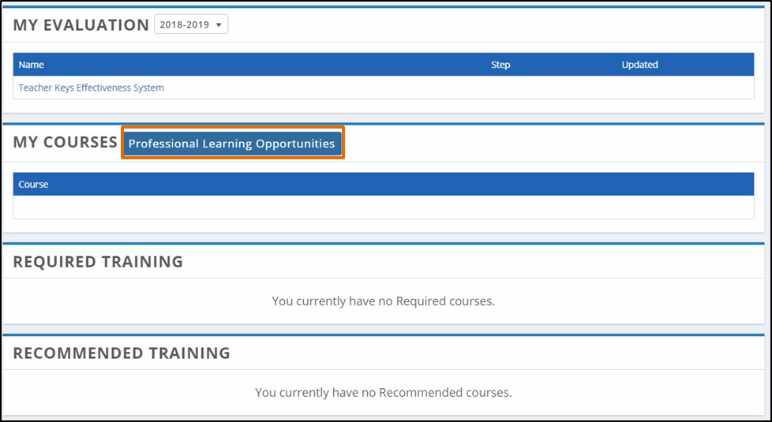
Professional Learning Registration
- Enter the Professional Learning landing page
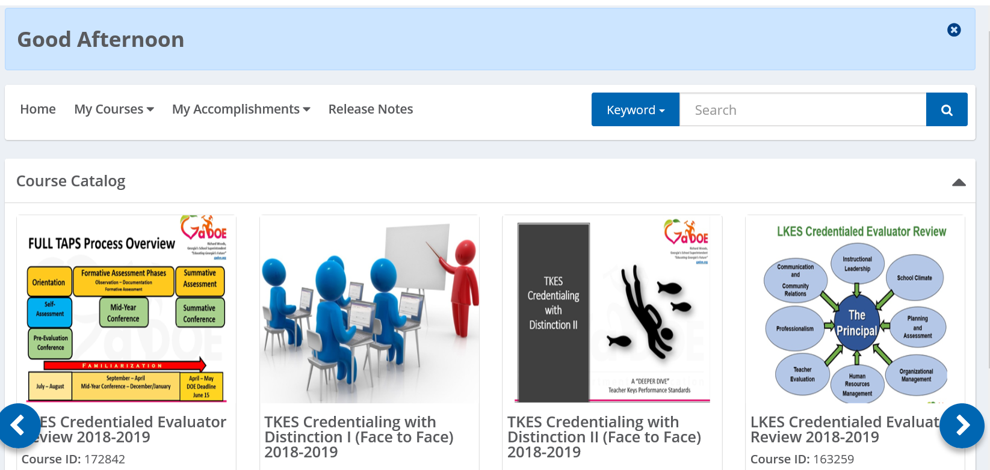

Click the down arrow next to Keyword and select Course Title. Then type the module name “[Three Dimensional Science Instruction]” in the search bar and press enter.
- The module should appear in the Available Training section.
- Click the Register button to enter the course.
- The course will now be available to start by clicking on course title after registering.

