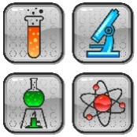
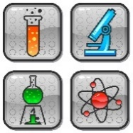
2019 Cobb/Paulding Regional Science & Engineering Fair
Registration and Application Instructions

Dear Local School Science Fair Winner,

Congratulations on winning your school’s Science Fair and advancing to the Regional Fair. In order to compete in this year’s Regional Science Fair please complete each of the following tasks:

1.) You must register on-line for the fair by going to https://www.populy.io/register/eZBwiW and completing the on-line registration form. In order to do so, you will need to know the title of your project, a parent/guardian’s e-mail, your science teacher’s e-mail, and a few details about your project. If needed, seek the help of your science teacher in order to complete the form. The deadline for on-line registration is Monday January 28th, 2019.
2.) In addition, you must submit photocopies of the appropriate forms for your project to your school’s Science Fair Coordinator by Monday, January 28th, 2019 (found at https://www.georgiacenter.uga.edu/sites/default/files/gsef-2019-required-forms-approvals.pdf). These forms should have be completed before the start of your research.
Please keep the originals in your possession. You will also need to bring an additional set of photocopies of these forms to the Regional Science Fair to keep in a 3-ring binder at your exhibit.

A confirmation/information email for each participating student will be sent to the e-mail addresses listed (student and parent) on the online registration form by Friday February 1st. It will include the details and directions for the science fair.

Thank you for your hard work in planning and presenting this research project. We look forward to seeing you on February 9th.

Good luck,

Christian Cali, Science Fair Co-Director
Sarah Graham, Science Fair Co-Director

