1st Grade Launch Unit
During the last few months of the 2019-2020 school year, some students may have not had the opportunity to master all the concepts of the previous grade level. This document will serve as a guide to help support any learning gaps that may have occurred.

Unit Topic: Plants and Animals
Estimated Time: 2 weeks
Standards:
SKL2. Obtain, evaluate, and communicate information to compare the similarities and differences in groups of organisms.
- Construct an argument supported by evidence for how animals can be grouped according to their features.
- Construct an argument supported by evidence for how plants can be grouped according to their features.
- Ask questions & make observations to identify the similarities & differences of offspring to their parents & to other members of the same species.
Disciplinary Core Idea: Life Science Learning Progression: Appendix A
Science and Engineering Practices & Crosscutting Concepts
Teacher Background Knowledge: Plants & Animals
Misconceptions: |  | Proper Conceptions:
- Bushes are baby trees  - Trees are only considered plants when they are small  - Trees, grass, vegetables, weeds are not plants  - Insects are not animals  - Humans are not animals  - All animals are 4 footed or furry  - All animals are large  - All animals live on land |  | - A shrub or bush is distinguished from a tree by its multiple stems and lower height, usually less than 6 m tall.  - A tree is a large plant. The term generally applies to plants at least 6 m (20 ft) high at maturity and having secondary branches supported on a main stem or stems.  - Trees and grasses are plants.  - A vegetable is the edible part of a plant.  - A weed in a general sense is a plant. More specifically, the term is often used to describe plants that grow and reproduce aggressively.  - Insects are part of the animal kingdom.  - Humans are part of the animal kingdom.  - Some animals are four footed and furry; others may have no legs, scales, etc. There is a wide variety of animals in the animal kingdom.  - Animals can be very small such as ants, ladybugs, etc.  - While some animals live on land, others can live in oceans, rivers or lakes.
Big Ideas/Enduring Understandings:  - Plants can be grouped by appearance, features, size, etc.  - Animals can be grouped together using features that can be observed (appearance, size, movement, etc.)  - Animals are similar and different in many ways. There are similarities and differences between parents and offspring.  - A child is similar and different from other children in the same family. |  | Essential Questions:  - How can I construct an argument to show how plants and animals can be grouped?  - How can I observe how parents and their offspring are similar and different?
Vocabulary:
Construct | Communicate | Obtain
Evaluate | Identify | Compare
Organism | Evidence | Argument
Grouped | Features | Plants
Observations | Similarities | Differences
Offspring | Parents | Members
Species

Literature Connections:  Do You Know Which Ones Will Grow? (Shea)  Living or Nonliving? (PebbleGo)  What’s Alive? (Zoehfeld)  A Tree is a Plant (Bulla)  Jack’s Garden (Cole)  Plants Feed Me (Rockwell)  Discovery Ed. Video: Living Things |  | STEM Careers:  Botanist Farmer Soil scientist  Gardener Landscaper Zoologist  Horticultural scientist Groomer  Golf course superintendent Veterinarian  Marine or wildlife biologist
Materials & Safety Considerations:  Lessons are designed with simplicity in mind. Use safety and caution when going outside for scavenger hunt and observation. |  | Distance Learning Options:  Lessons can be easily adapted to distance learning with the use of a document camera for card sorts.
Probes:
Launch the unit with the following probes to see where your students are at in their learning:
- Is it Living?
- Is it an Animal?
- Is it a Plant?
Each probe is linked to a primary card sort. Use the information from the sort to guide your lessons. Revisit the sorts throughout the unit if necessary.
Lesson Components
PHENOMENA
Topic 1: Construct an argument supported by evidence for how animals can be grouped according to their features.  One way to sort animals is by body covering (fur, scales, skin, feathers) | Topic 2: Construct an argument supported by evidence for how plants can be grouped according to their features.  Plants have similar parts, but those parts look different on different types of plants. (a tree has a trunk, herbs have fragile stems) |  | Topic 3: Ask questions & make observations to identify the similarities & differences of offspring to their parents & to other members of the same species.  Animal babies have similar features to the animal parent.
ENGAGE
Topic 1: Construct an argument supported by evidence for how animals can be grouped according to their features.  *Activity to be used for Task 1&2  Go outside on a scavenger hunt. How many different plants and animals can you find?  Recording sheet | Topic 2: Construct an argument supported by evidence for how plants can be grouped according to their features.  (see Topic 1 for activity) |  | Topic 3: Ask questions & make observations to identify the similarities & differences of offspring to their parents & to other members of the same species.  The baby animal song: https://www.youtube.com/watch?v=cJg4YFtvOp8  Hand out animal cards to students. One group will receive a picture of the adult animal. The other group will be given a matching baby animal picture. Students will need to find their animal match. Ask student pairs explain how they decided they belonged together.  Animal with Baby cards
EXPLORE
Topic 1: Construct an argument supported by evidence for how animals can be grouped according to their features.  Each table group will be given a set of animal cards. Ask the group to discuss and sort the animals. They should be able to explain the “rule” to their sort. Can the cards be sorted more than one way?  If available, you can also use animal figures.  Animal sort cards | Topic 2: Construct an argument supported by evidence for how plants can be grouped according to their features.  Place on each table a set of 3 pictures. The set should be of one type of plant (tree, bush, flower, vine). Hand each student a picture of a plant. Ask students to decide which group their picture belongs to. Students should be able to defend their reason for the placement.  If possible, have a variety of plant type available for students to observe. Or go back outside and look at the different types of plants around the school.  Plant picture sort cards |  | Topic 3: Ask questions & make observations to identify the similarities & differences of offspring to their parents & to other members of the same species.  Using the partner groups from the engage activity. Partner groups will create Venn diagram to compare the adult and baby animal on their cards. Students are making claims and giving supporting evidence.  Do a gallery walk and have students make observations. Chart any questions for further investigation.
EXPLAIN
Topic 1: Construct an argument supported by evidence for how animals can be grouped according to their features.  Animal Classification Game  PebbleGo! Resources (Cobb Digital Library) | Topic 2: Construct an argument supported by evidence for how plants can be grouped according to their features.  Plant classification video  PebbleGo! Resources (Cobb Digital Library)  Plants (Discovery Ed. full video)  Based on observations made outside, have students group the various plants found outside from the scavenger hunt. What are their claims and evidence? |  | Topic 3: Ask questions & make observations to identify the similarities & differences of offspring to their parents & to other members of the same species.  Animals and Babies PowerPoint
EXPAND
Topic 1: Construct an argument supported by evidence for how animals can be grouped according to their features.  Look up a map of Zoo Atlanta. Discuss how the animals are grouped. If you could add another animal exhibit, what would it be? Where would it go? How do you decide? | Topic 2: Construct an argument supported by evidence for how plants can be grouped according to their features.  Plan a garden for your (school, park, yard). What would your dream garden look like? What plants would grow there? How would you group the plants? |  | Topic 3: Ask questions & make observations to identify the similarities & differences of offspring to their parents & to other members of the same species.
HMH Resources
HMH Dimensions  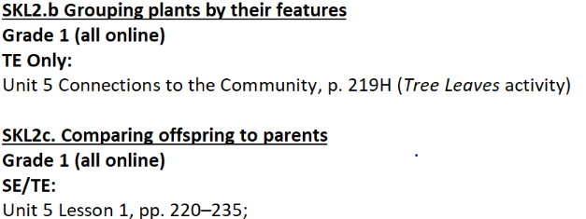  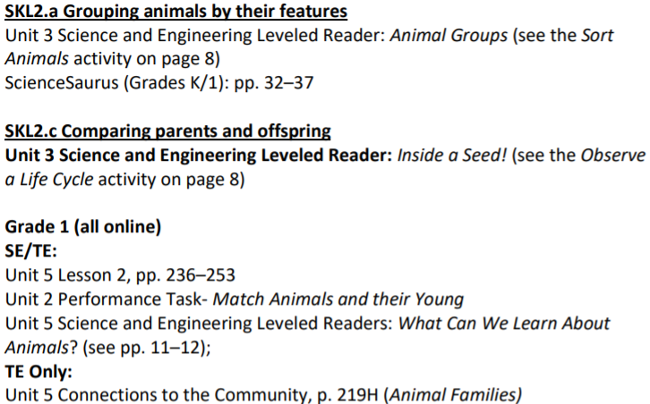 |  | HMH GA Science Resources (online)  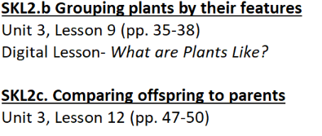  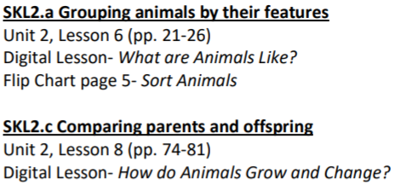
Differentiation:
- Vary reading level according to student needs
- Adjust the number of cards in sort if needed
- Provide word banks and pictures when necessary
- Partner students according to student needs
Evaluate (Closing): What type of assessment will you give to evaluate students? (Note: the assessment may be your “elaborate” activity)
Or you may revisit the probes from the beginning of the unit.

Appendix A
Disciplinary Core Idea: Life Science Learning Progression
K & 1st | 2nd | 5th | 7th | High School
SKL1. Obtain, evaluate, and communicate information about how organisms (alive and not alive) and non-living objects are grouped.  a. Construct an explanation based on observations to recognize the differences between organisms and nonliving objects.  b. Develop a model to represent how a set of organisms and nonliving objects are sorted into groups based on their attributes.  SKL2. Obtain, evaluate, and communicate information to compare the similarities and differences in groups of organisms.  a. Construct an argument supported by evidence for how animals can be grouped according to their features.  b. Construct an argument supported by evidence for how plants can be grouped according to their features.  c. Ask questions and make observations to identify the similarities and differences of offspring to their parents and to other members of the same species.  First Grade:  S1L1. Obtain, evaluate, and communicate information about the basic needs of plants and animals.  a. Develop models to identify the parts of a plant—root, stem, leaf, and flower.  b. Ask questions to compare and contrast the basic needs of plants (air, water, light, and nutrients) and animals (air, water, food, and shelter).  c. Design a solution to ensure that a plant or animal has all of its needs met. | S2L1. Obtain, evaluate, and communicate information about the life cycles of different living organisms.  a. Ask questions to determine the sequence of the life cycle of common animals in your area: a mammal such as a cat, dog or classroom pet, a bird such as a chicken, an amphibian such as a frog, and an insect such as a butterfly.  b. Plan and carry out an investigation of the life cycle of a plant by growing a plant from a seed and by recording changes over a period of time.  c. Construct an explanation of an animal’s role in dispersing seeds or in the pollination of plants.  d. Develop models to illustrate the unique and diverse life cycles of organisms other than humans. | S5L1. Obtain, evaluate, and communicate information to group organisms using scientific classification procedures.  a. Develop a model that illustrates how animals are sorted into groups (vertebrate and invertebrate) and how vertebrates are sorted into groups (fish, amphibian, reptile, bird, and mammal) using data from multiple sources.  b. Develop a model that illustrates how plants are sorted into groups (seed producers, non-seed producers) using data from multiple sources. | S7L1. Obtain, evaluate, and communicate information to investigate the diversity of living organisms and how they can be compared scientifically.  a. Develop and defend a model that categorizes organisms based on common characteristics.  b. Evaluate historical models of how organisms were classified based on physical characteristics and how that led to the six kingdom system (currently archaea, bacteria, protists, fungi, plants, and animals).  (Clarification statement: This includes common examples and characteristics such as, but not limited to, prokaryotic, eukaryotic, unicellular, multicellular, asexual reproduction, sexual reproduction, autotroph, heterotroph, and unique cell structures. Modern classification will be addressed in high school.) | SB4. Obtain, evaluate, and communicate information to illustrate the organization of interacting systems within single-celled and multi-celled organisms.  a. Construct an argument supported by scientific information to explain patterns in structures and function among clades of organisms, including the origin of eukaryotes by endosymbiosis. Clades should include:  - archaea  - bacteria  - eukaryotes  - fungi  - plants  - animals  (Clarification statement: This is reflective of 21st century classification schemes and nested hierarchy of clades and is intended to develop a foundation for comparing major groups of organisms. The term 'protists' is useful in describing those eukaryotes that are not within the animal, fungal or plant clades but the term does not describe a well-defined clade or a natural taxonomic group.)  b. Analyze and interpret data to develop models (i.e., cladograms and phylogenetic trees) based on patterns of common ancestry and the theory of evolution to determine relationships among major groups of organisms.  c. Construct an argument using valid and reliable sources to support the claim that evidence from comparative morphology (analogous vs. homologous structures), embryology, biochemistry (protein sequence) and genetics support the theory that all living organisms are related by way of common descent.  d. Develop and use mathematical models to support explanations of how undirected genetic changes in natural selection and genetic drift have led to changes in populations of organisms.  (Clarification statement: Element is intended to focus on basic statistical and graphic analysis. Hardy Weinberg would be an optional application to address this element.)  e. Develop a model to explain the role natural selection plays in causing biological resistance (e.g., pesticides, antibiotic resistance, and influenza vaccines).

